* **Project Title : Christmas Day**
* **Course : Computer Graphics**
* **Group : 9**
* **Section : H**
* **Group Member:**

1. MASHRUR HOSSAIN - 18-36218-1
2. Nadim Hossain - 18-36703-1
3. Farhan Hassan Jabil -18-36216-1
4. Chowdhury,Anik - 18-38387-2

**Introduction:**

Our project is "Christmas Day “where a scene of total view implemented in opengl. We have mainly created some artifacts in this project like sky, Christmas tree, cloud, road, hill, house, Santa Claus, snowman etc. Day modes and night modes also have been used here. In this project we have highlighted Christmas day view that means overall scenario of infrastructure. The sky and there will be cloud will be moving forward and backward side. Santa Claus stands beside the tree. There is a day and night mode in which there will be sun and cloud in the sky and clouds will be moving.

**Objective:**

The objective is this project to create a view of Christmas day and highlight all specific sectional view.

When we press space button then we strat the project.when we press N then it will be night and press day for day.

**Background Study:**

To implement this project, we had to look into every small details and group them to increase efficiency of function usage. Such as, we can use same set of functions for trees, clouds, santa claus can be drawn using same set of functions. After grouping we studied some glut functions which helped us shape the project. We also had to clear our understanding on graphical curves. Without graphical curves we could not draw wheels and other shapes. Also, we had to learn the scaling method for maintaining the resolution of glut screen. After that we chose the appropriate function set that will draw the project items. The list of functions which we studied and used in this project are given below:

glClearColor: specify clear values for the color buffers.

glPointSize: specify the diameter of rasterized points.

gluOrtho2D: define a 2D orthographic projection matrix

glVertex2i: specify a vertex

glPushMatrix: push the current matrix stack

glTranslatef: add the current matrix by a translation matrix

glColor3ub: sets the current color

glVertex2f: Specifies a vertex

glPopMatrix: pop the current matrix stack

glScalef: multiply the current matrix by a general scaling matrix.

glutTimerFunc: registers a timer callback to be triggered in a specified number of milliseconds.

glutKeyboardFunc: sets the keyboard callback for the current window and also trigger day night mode.

glutInit: A pointer to the program's unmodified argc variable from main. Upon return, the value pointed to by argcp will be updated, because glutInit extracts any command line options intended for the GLUT library

glutInitWindowSize: set the initial window position and size respectively

**IMPLEMENTATION:**

* + **Code:**

**Significant:**

This is a special day for celebrating a christmas day to all of people in the world.

All this things related to a special day is so much attractive and enjoying moment attached.

So we think this project plays a significant role.

**Conclusion:**

We have tried our best to highlighting whats is happen in chrismas day .Though It's a very enjoyable project for us.In further future we will try to implement every single portion carefully.

**Screenshot:**

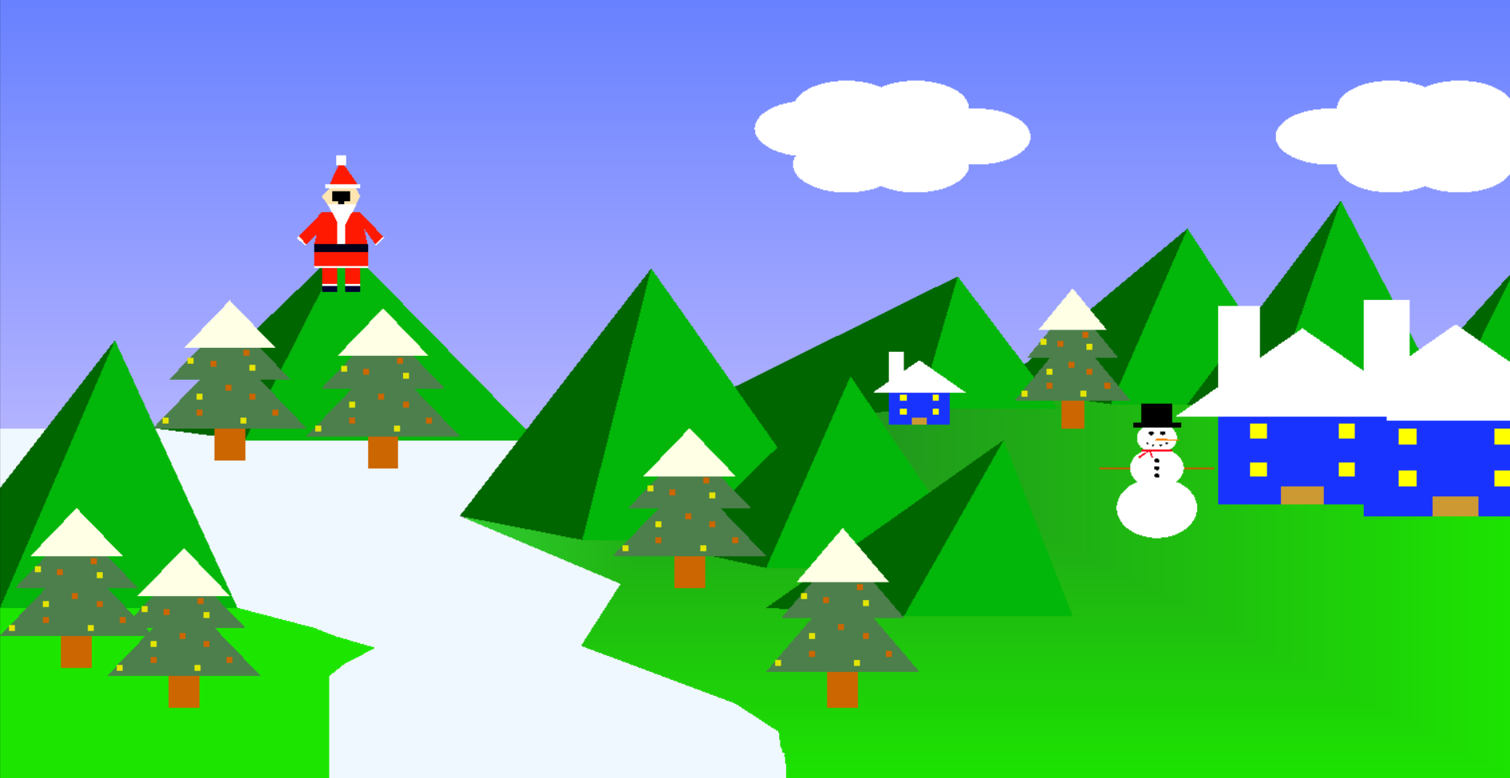

**Thank you**